# 

# **Introduction**

Welcome to your favorite AICT Lab. In this lab manual, we shall work together to learn and implement new computing concepts.

### 

### **Skills to be learned:**

* MS Office
* MS PowerPoint– Slide design, themes, animations, charts/media, interactive presentations.

| Week 6 | Orientation of Power point  Choose and Create: Animated story  Create the Truth tables of OR, AND & XOR  Develop the solar system by animation  Lab Project: Group members introduction | CLO3 |
| --- | --- | --- |

### 

**Let's do some computing**

**Good Luck and Best Wishes !!**

**Happy Computing ahead :)**

**MS Office**

MS PowerPoint

Professional

Documentations

**Introduction to MS PowerPoint**

Microsoft PowerPoint is an electronic presentation program that helps people present a speech using a collection of slides. A PowerPoint presentation is a collection of slides that can be used to create oral presentations.

**Starting PowerPoint**

Click on the start button and select all programs. Select Microsoft office and click on MS Power Point. You can also search for PowerPoint in the search bar. Or you can directly start it from the short-cut available on the desktop.



*Figure 48-starting power point*

**Program window**

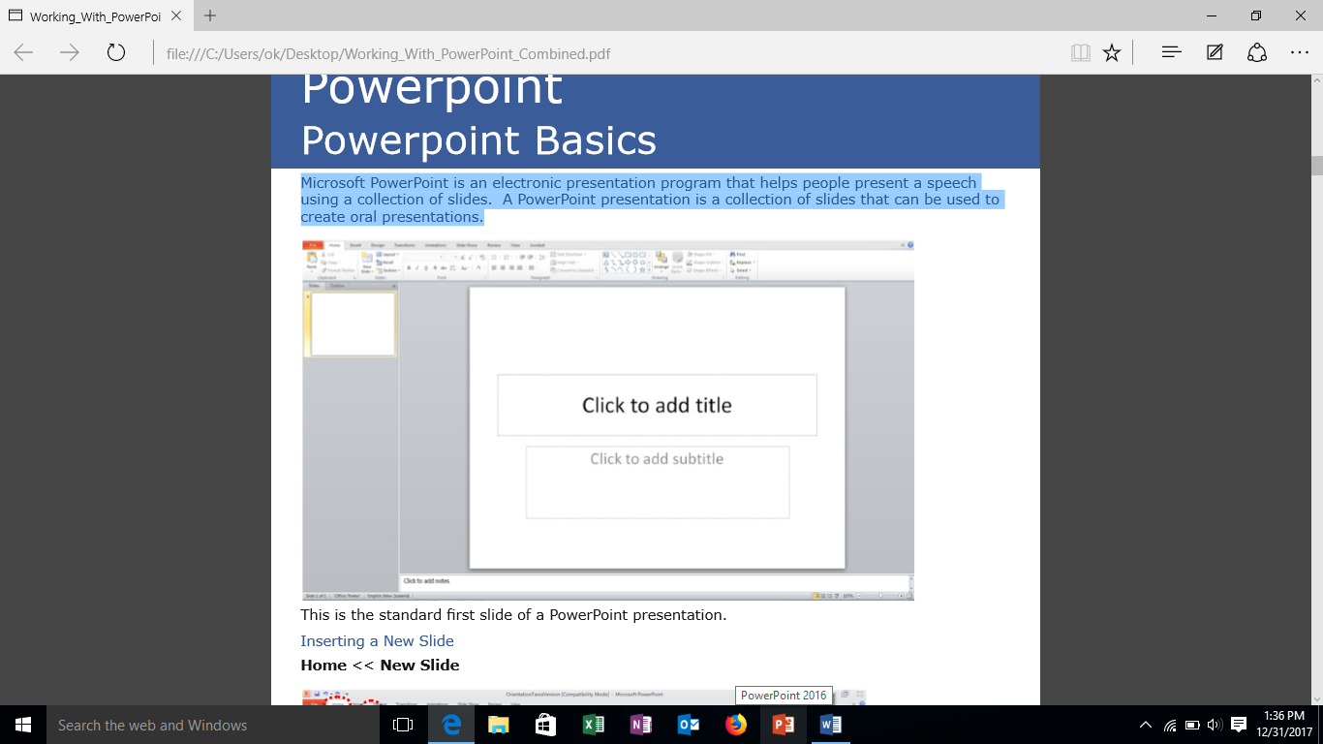

*Figure 49: Initial Window*

**Different actions to be performed in power point:**

**Deleting a slide**

Select the slide that you would like to delete and press the Delete key on the keyboard OR right click on the selected slide and select Delete Slide from the menu

**Copying a Slide**

Select the slide you would like to copy, right click on the selected slide and select Copy from the menu.

**Pasting a Slide**

Position your cursor where you want to paste the slide and press Ctrl + V

**Moving a slide**

After creating a PowerPoint presentation you may decide to change the order of your slides. Select the slide you wish to move (a border will appear around the selected slide), and drag the slide to where you want to reposition it and drop it into the position. The slide number sequence will automatically update.

**Inserting charts in power point**

To insert a chart, select the slide where you want to insert the slide and go to the insert tab and click on charts. Charts dialog box will appear. And select the desired chart. And click OK. An excel window will open so you can directly enter/edit data.

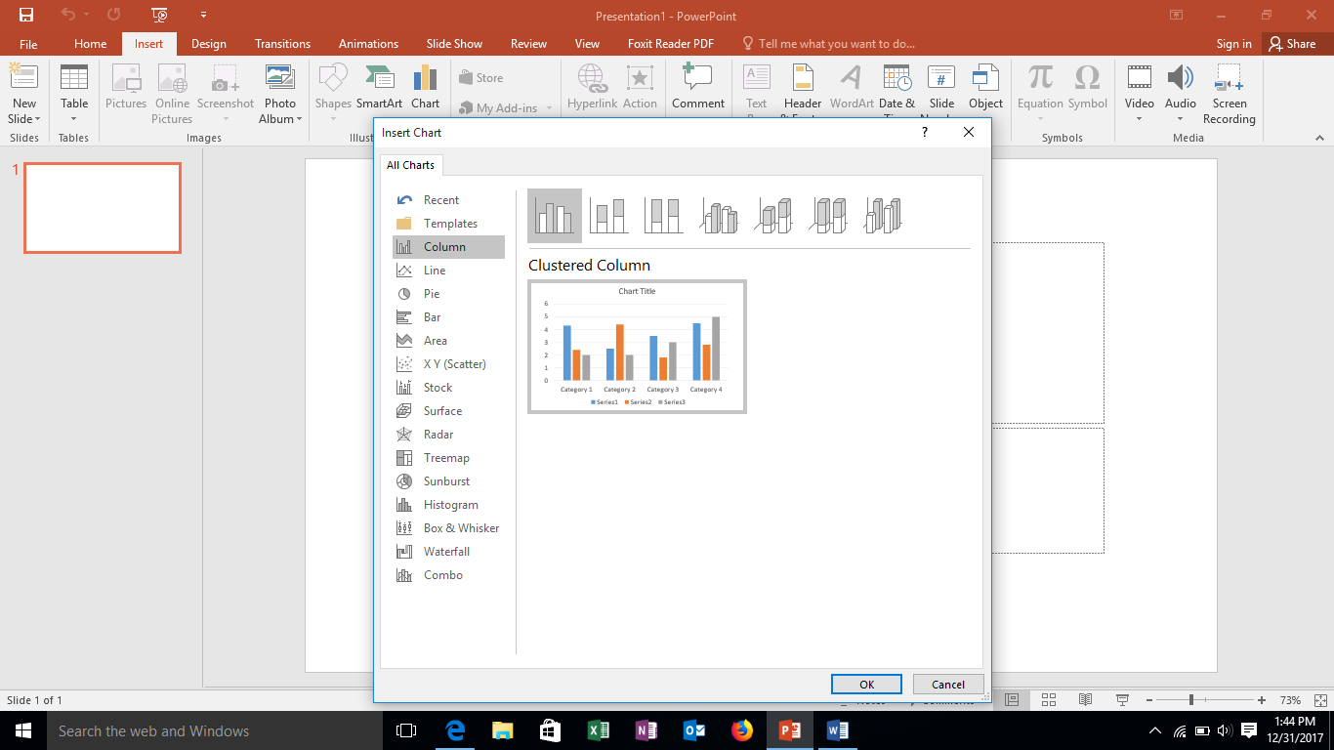

*Figure 50-inserting chart*

**Inserting diagrams in power point**

Go to insert tab and select smart art. A dialog box will appear. Select the desired shape and click OK.

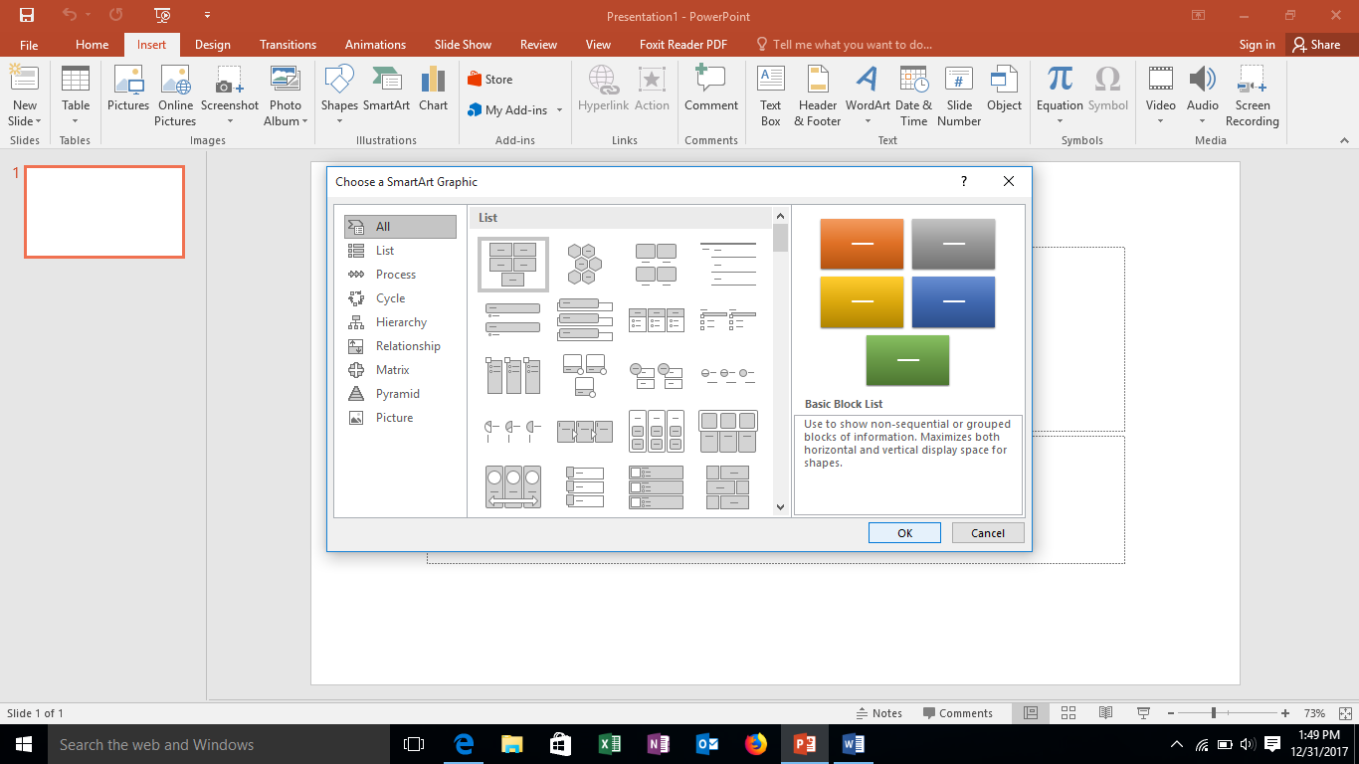

*Figure 51-inserting diagrams.*

**Inserting audio in power point**

Click the insert tab and click on audio and select audio on my PC. Insert audio box will appear.

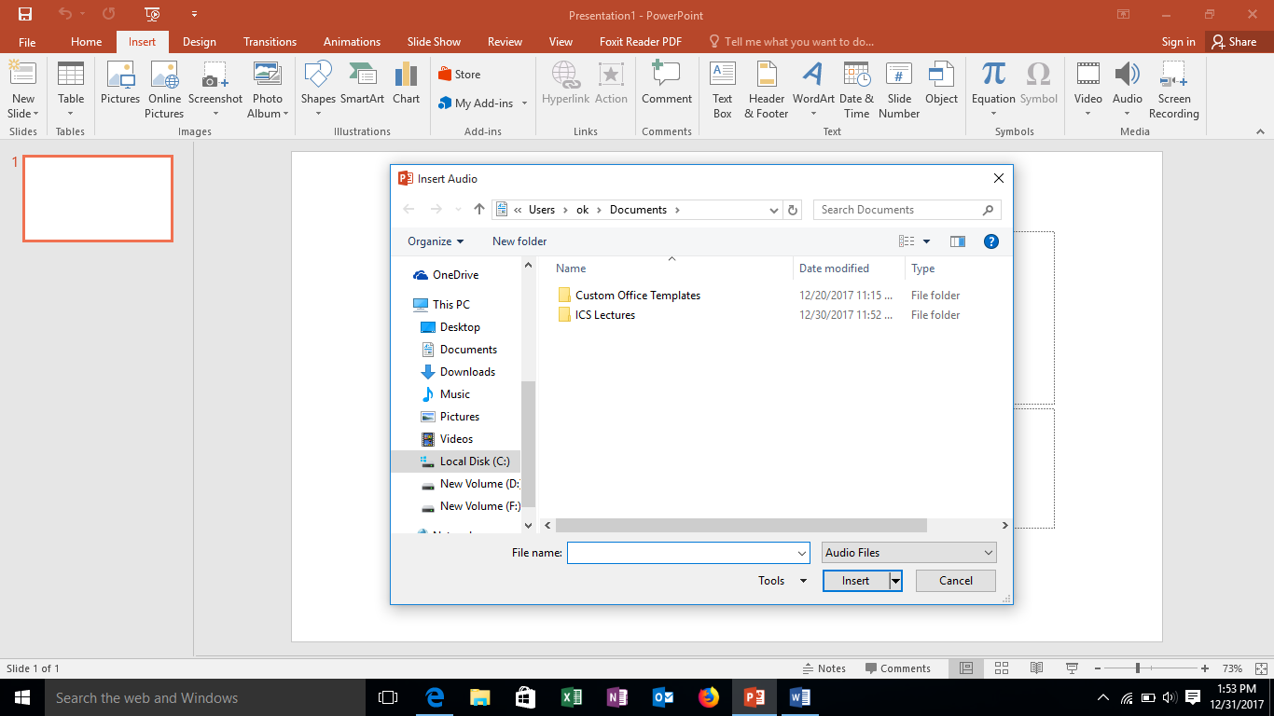

*Figure 52-inserting audio*

Browse for your sound file and click insert. Sound will be added.

**Inserting video in power point**

Go to the insert tab and click on the video button and select video on my PC.

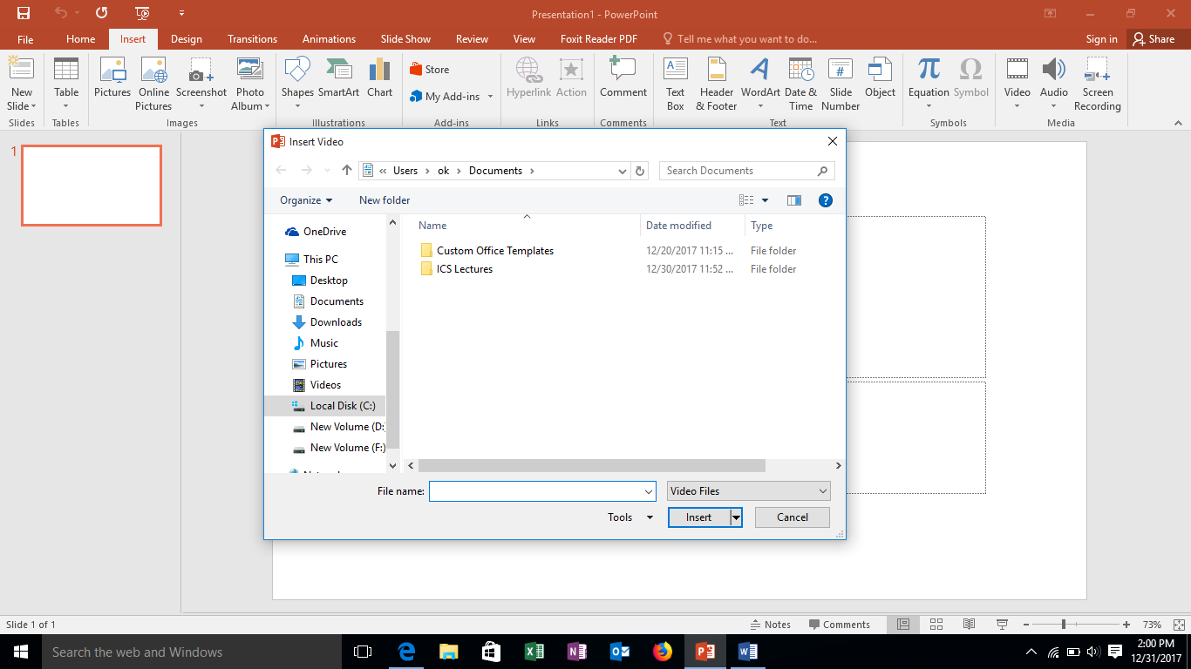

*Figure 53-inserting video*

Browse for your video and click **Insert**.

**Exiting power point**

You can exit the power point by clicking the close button at the upper right corner. Or select the file tab and click on close option.

**CS-141L Introduction to computing**

**Create a solar system in MS PowerPoint.**

**Objectives**

To learn how to insert pictures in power point and apply animation to them.

**Processing steps**

**Opening a blank presentation**

Start Ms Power point and select a blank presentation to make a new slide.

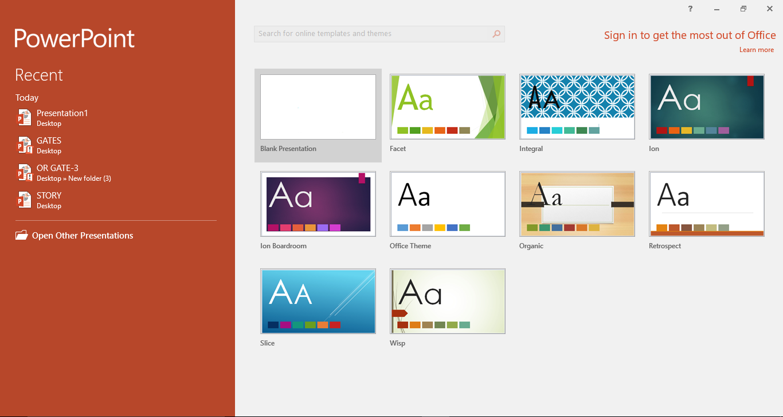

*Figure 54-opening blank slide*

**Adding background**

To insert background in the slide, select the design tab and click on the format background button in the customize group. **Format background pane** will appear. 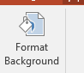

From format background select fill section and then select picture or **texture fill** and then click on file option.

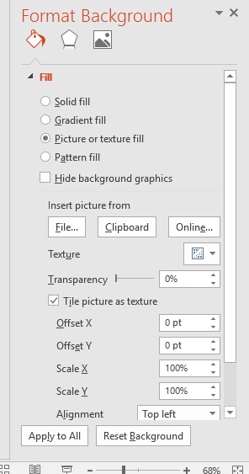

*Figure 55-format background*

**Insert picture** dialog box will appear. Select the desired picture for your background and click on **Insert**.

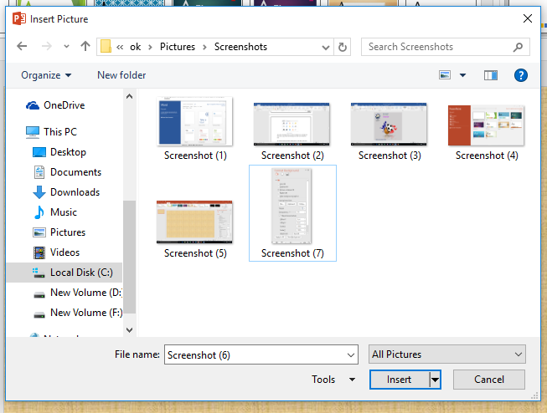

*Figure 56-inserting picture as a background*

**Inserting shapes**

After inserting the background, the next step is to insert circular strands. This can be done by using shapes in powerpoint. Click on the insert tab and on the illustrations group, select **shapes button.** Select the desired shape from **drop down** list (oval in this case).

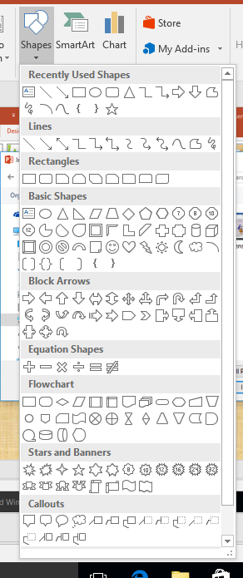

*Figure 57: Shapes*

To make multiple circular strands, press **Ctrl+D** and then resize each strand.

**Formatting shapes**

To change the colour of shapes, select the shape to activate **format bar**. And on the shape styles group select shape fill to change colour of shape and shape outline to change the colour of the outline (in this case shape fill is selected to no fill and shape outline is white).

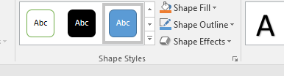

*Figure 58-formatting shapes*

**Inserting and formatting pictures**

Now start inserting pictures in the slide (in this assignment pictures of planets are inserted). To insert pictures, click on the insert tab and select pictures button. **Insert picture** dialog box will appear. Select the pictures one by one and then click insert.



*Figure 59-insert pictures*

To format the pictures, double click on the picture to **activate** format bar. Change Picture style of all the pictures if required (I have applied soft edge oval style to all the pictures)

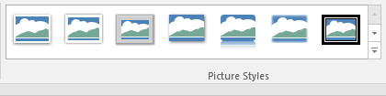

*Figure 60-picture styles*

**Applying animation**

The next step is to apply animation. Select the image and click on the **animation** tab and select the desired animation to view all animations click on the arrows available in the animation group. (I have selected shapes animation available in motion path categories)



*Figure 61-animation tab*

Set the shape size on **the circular strands**. Select the shape and double click it and drag it to the desired position.

Now activate the animation pane. To do this click on the animation pane button in **animation tab.**

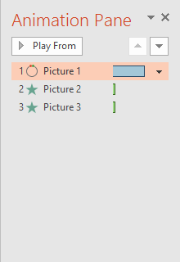

*Figure 62-animation pane*

Duration and delay for each animation can be defined in the **animation pane** by selecting the animation and clicking on the arrow next to that animation and selecting the **timing option.**

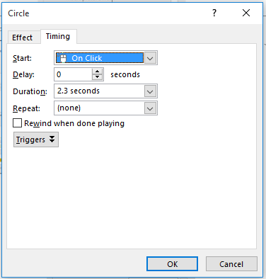

*Figure 63-adjust timing*

To make one animation start with the previous one select the start with previous option and check the option of start on click (in this case all the animations are set to start with previous).

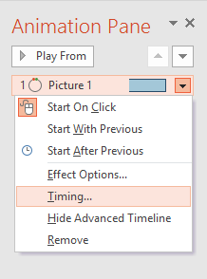

*Figure 64-formatting of animation*

You can view the preview of these animations by clicking in the preview button in the animation tab.

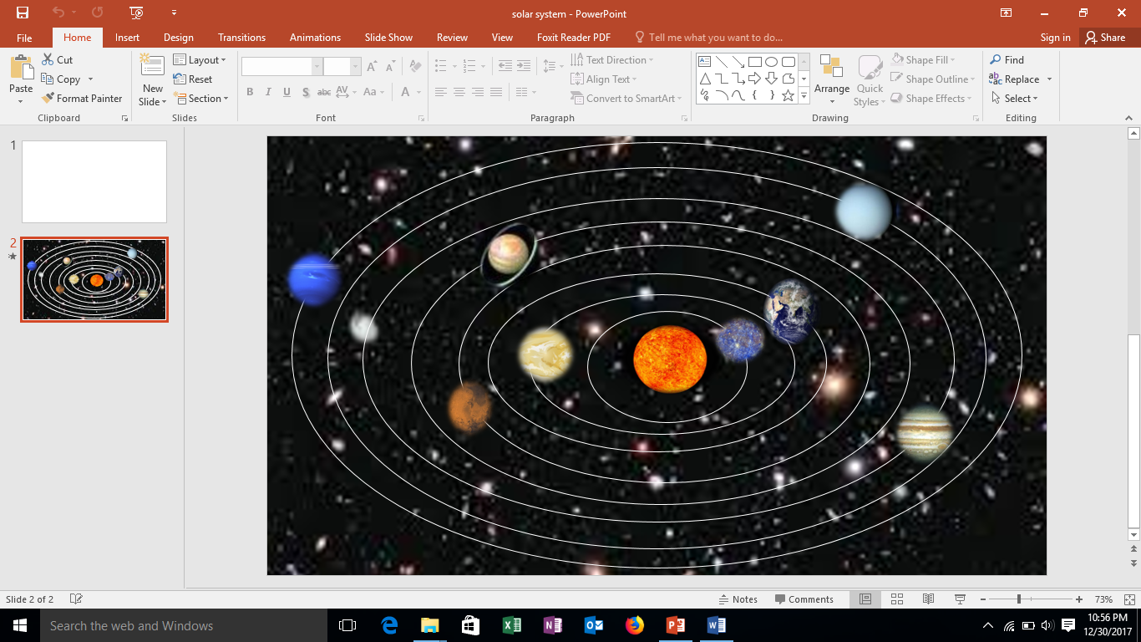

*Figure 65- preview*

**Saving presentation**

After applying animation and formatting them, you can save the presentation. Click on the file tab and then select save as and then further select **browse option.**

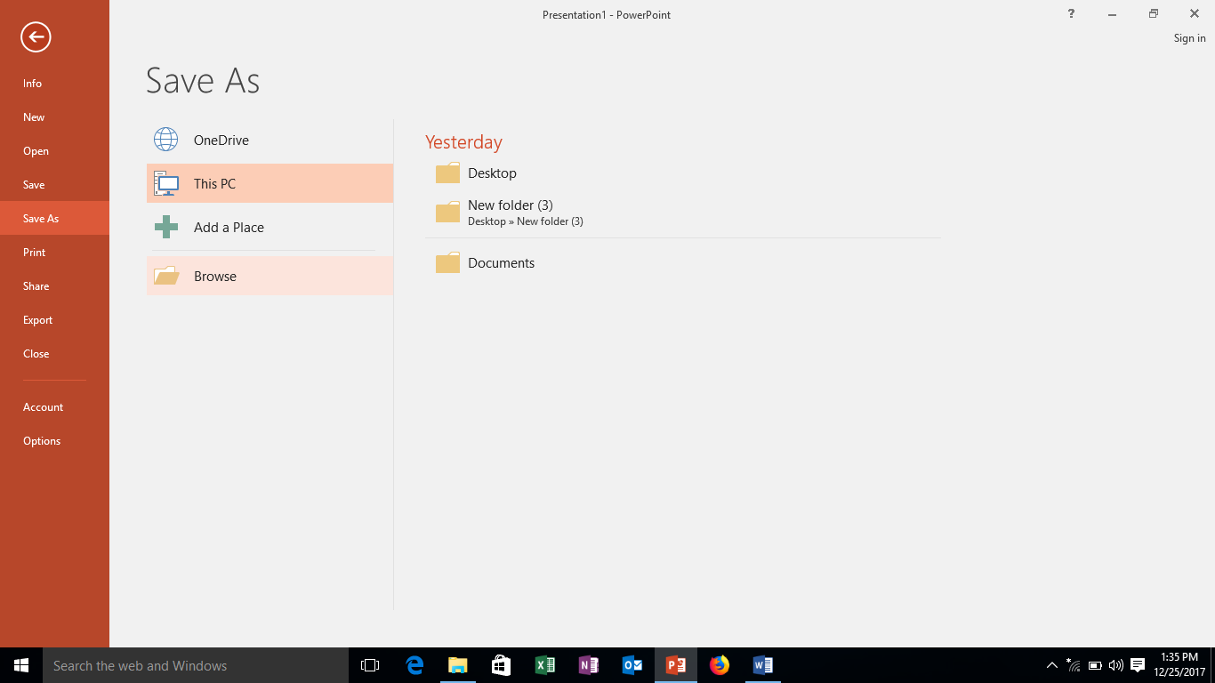

*Figure 66-saving presentation*

**Save** as dialog box will appear. Enter the desired name of the presentation in the file name box and save as type and then click save. Your presentation will be saved with a specified name and at specified location.

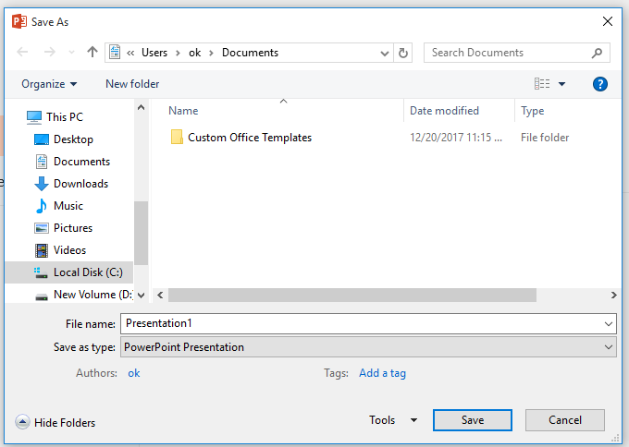

*Figure 67- save as dialog box*

**Conclusion**

After following the above steps, we will be able to insert background, pictures and format them. We can add animation and set its timing.

**Sample**

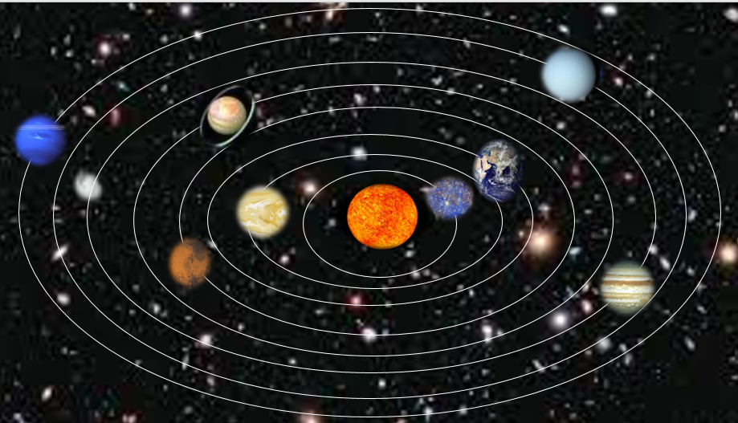

*Figure 68: Sample document*

**CS-141L Introduction to computing**

**Create an animated story.**

**Objectives**

To learn how to add different animations at the same time and how to sync them.

**Processing steps**

1. Start power point and select blank presentation as explained in the assignment 1. Getting Blank slide
2. On **Home** tab, click on **Layout** and select **Blank** from the list.

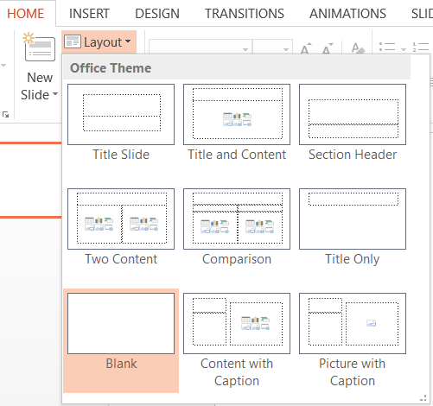

*Figure 69-blank slide*

1. Insert picture as a background related the task as per procedure explained in the assignment

**Removing background of images to be inserted**

1. Insert the images in the slide related to the story and format them. **Remove background** of the inserted images if required. This can be done by selecting the picture to activate the format bar and select remove background.

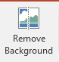

*Figure 70: remove background button*

1. Format the pictures and place them in the slide and apply animations on the pictures.
2. In this slide I have inserted 3 images (mother, daughter and bucket).

 

1. Now start applying desired animation on the images (in this case I have applied one animation on mother image i.e., **float in** and one on daughter image and two animations on bucket i.e**., float in and pulse**)
2. You can also insert different shapes in the slide as explained above (in this slide I have used cloud callout shape available in the callout group)

**Inserting text in shapes**

1. Insert text and format the shapes, select the shape and select option edit text and start adding text in the shape.

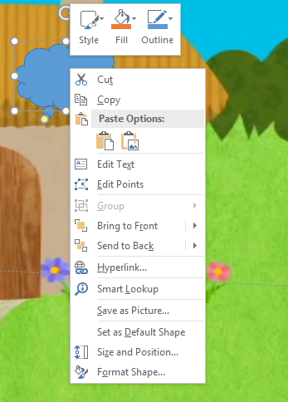

*Figure 71-adding text in shapes*

**Applying multiple animation**

1. To apply multiple animations on an image, select the image and apply first animation as explained in assignment 1 and for second animation click the down arrow next to add animation button in the **animations tab.**



*Figure 72: add animation button*

**Viewing Slide show**

1. Set the duration and delay for each image. You can view the slide show of the slide by clicking on the slide show tab and selecting ‘**’from current slide**’’ option in the start slide show group.

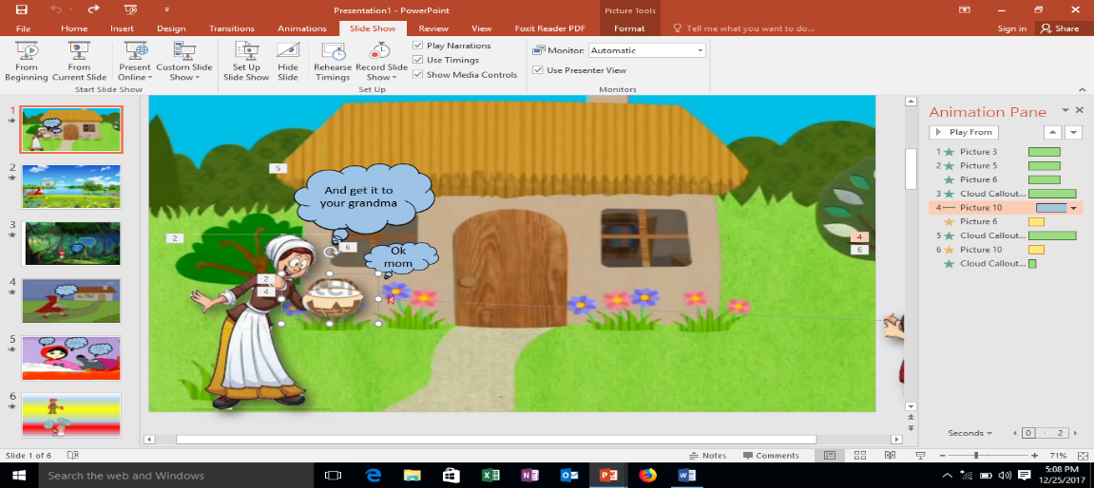

*Figure 73-viewing slide show*

**Adding new slide**

1. After completion of the first slide add a second slide. In the home tab select the **new slide** button and add a blank slide.

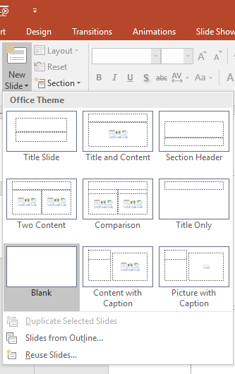

*Figure 74-adding new slide*

1. In the second slide again insert different pictures and apply animations on them. You can also add different effects on the animation path. This can be done from the ‘**’effects options’’** available in the animations tab.

**Applying effects to animation**

1. To apply effects on animation, first apply animation on picture and then select **Effect** **Options**.

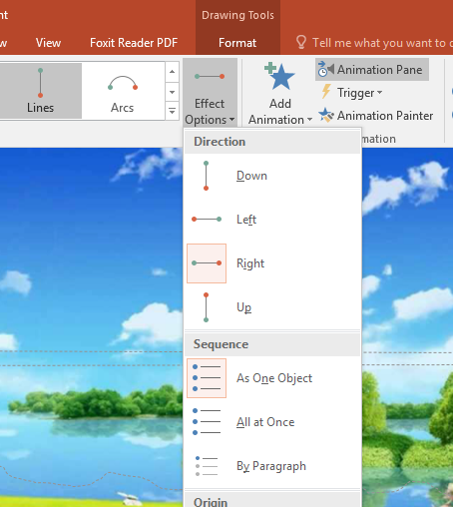

*Figure 75-animation effects*

1. To arrange the animations in sequence, press and hold the animation in the **animation pane** and drag it to the desired position.

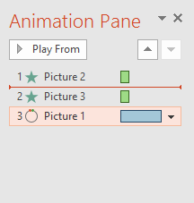

*Figure 76-sequencing animation*

1. To define your own motion path in animation, select the **custom path.**
2. Apply animations and effects on the images inserted and check its slide show.

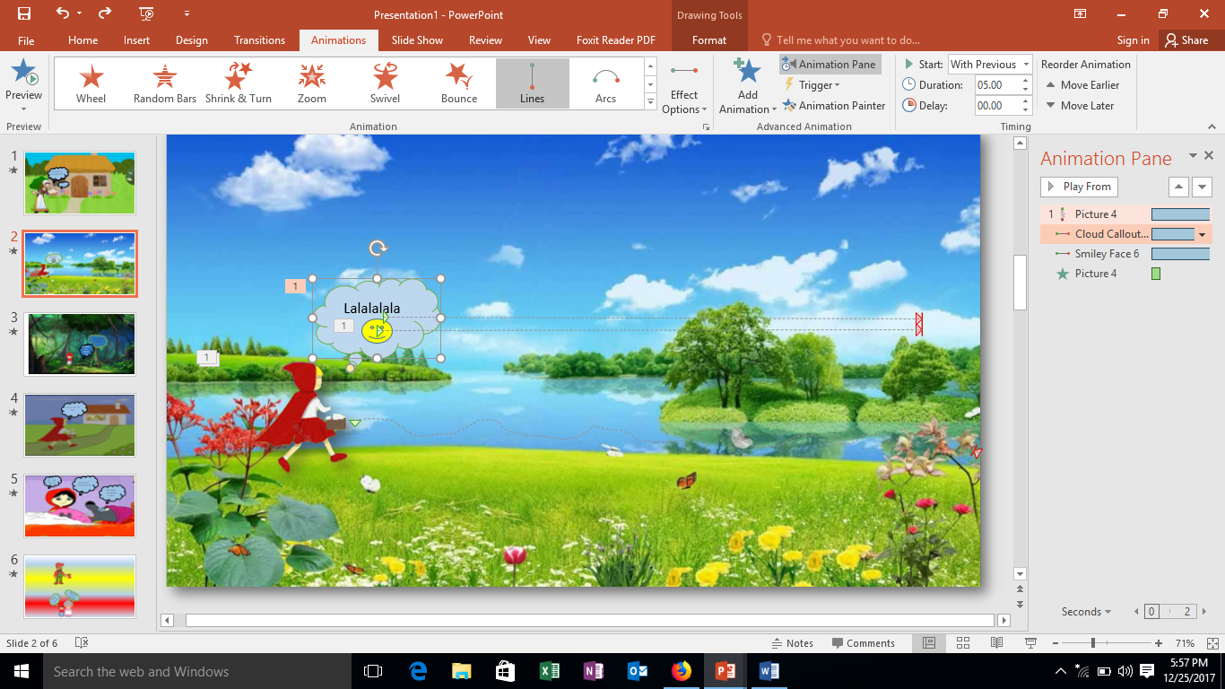

*Figure 77: Applying Animations*

1. Now in the third slide again insert the desired pictures and shapes, format them and apply animations on them( in this slide I have applied arc and grow/shrink animation on wolf image and line and pulse animation on girl image and wipe and fade on callouts and line animation on bucket)
2. Sequence all the animations and check the slideshow of the current slide.

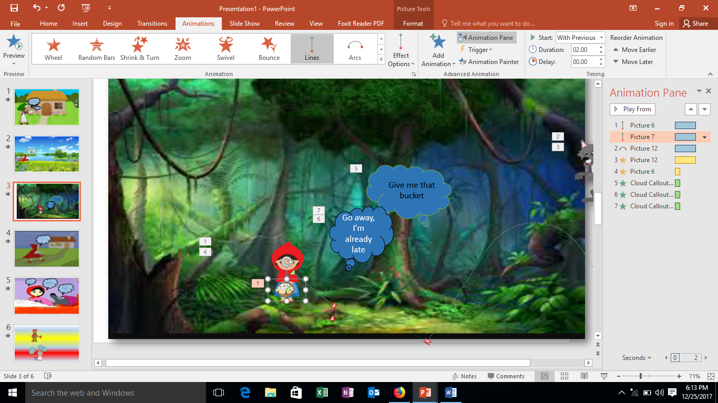

*Figure 78: Adding Images*

1. Similarly insert picture and callout in the fourth slide and apply animation on them (I have applied fade animation on the shape). Check the slide show.

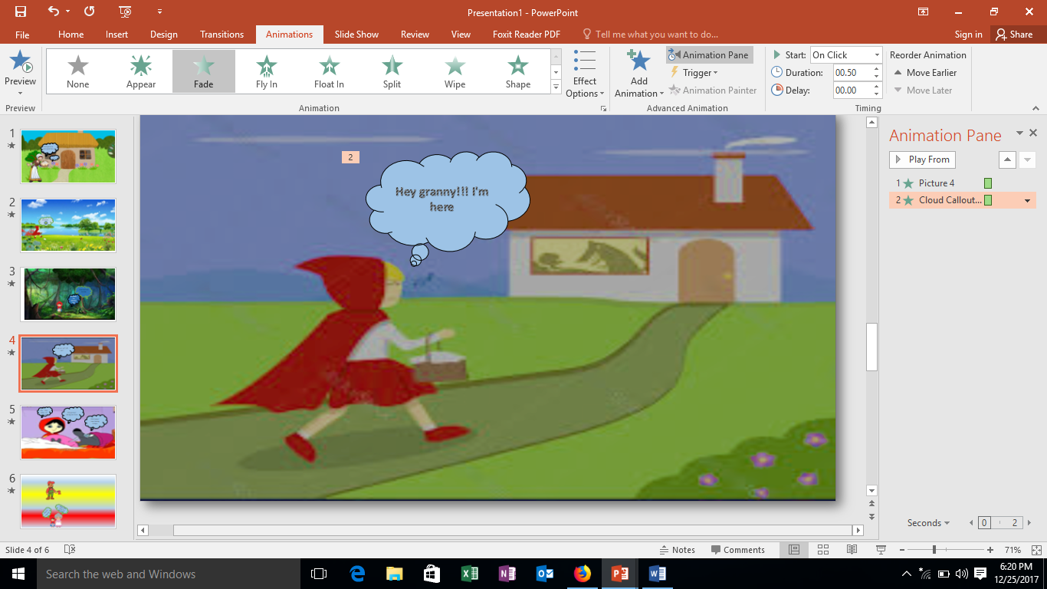

*Figure 79: Slide show*

1. In the fifth slide again add pictures and shapes and apply animation on them( I have applied **Fade animation** on shapes and line animation on grandma’s image)

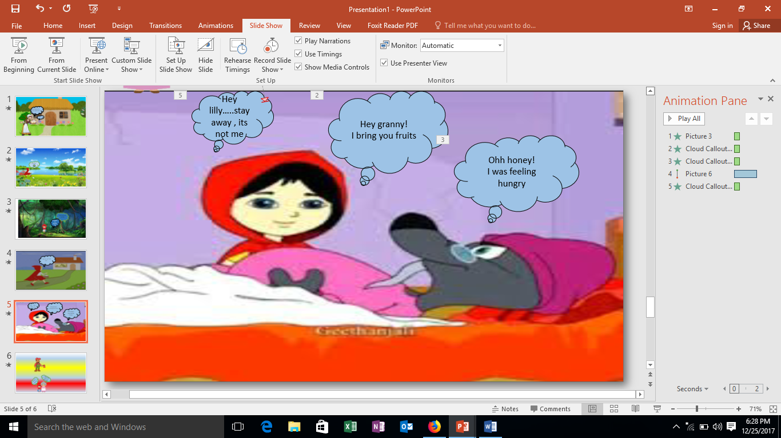

*Figure 80 Applying Fade Animation*

1. In the fifth slide, create a different background. To do this, go to the **Design** tab and then select **Format Background** and select the desired background (picture and texture etc.)

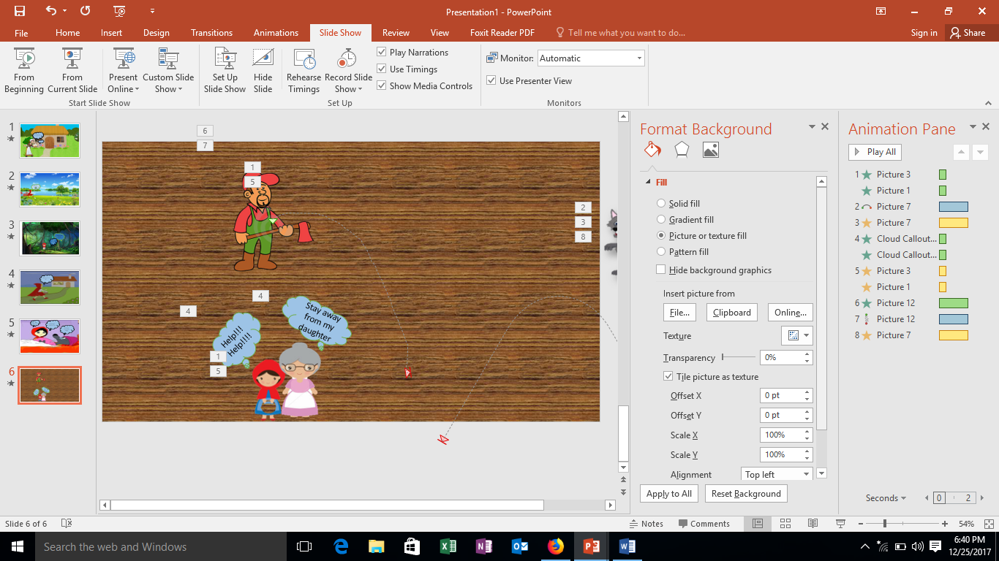

*Figure 81-inserting background*

**Applying transitions**

1. You can also add transitions to the slides. This can be done by selecting the **transitions tab** and then select the desired transitions. (in this presentation I have used curtains, wind, push, random bars and ripples)

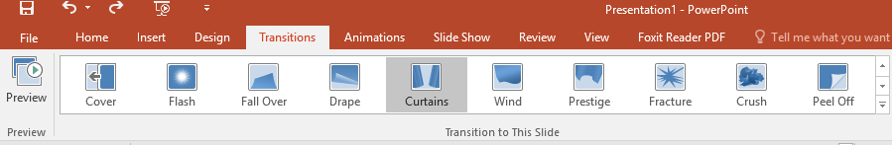

*Figure 82-adding transitions*

After completing the presentation, you can save it with the procedure explained in lab 01.

**Conclusion**

After following the above steps, one can learn how to insert pictures, shapes and animation in slides. How to add new slides and multiple animations and transitions on different slides.

**CS-141L Introduction to computing**

**Create OR, AND, and XOR gate using bit animation.**

**Objectives**

To learn how to insert tables in powerpoint and apply animation to numbers.

**Processing steps**

1. Start power point and open a blank presentation.
2. First of all, add background in the slide. Go to the design tab, click on the format background button and select the pattern fill button. Then select the desired background.
3. After adding background, insert text box at the top and heading in it.

**Inserting table**

1. Insert table in the slide. To do this, select **insert tab** and click on the table button to select the desired no rows and columns.

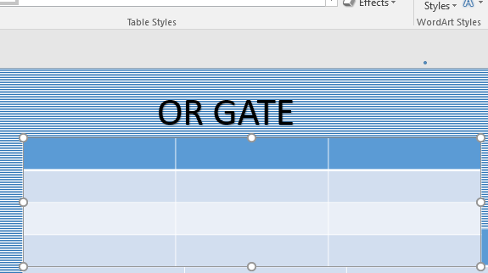

*Figure 83- inserting table*

1. Add inputs and outputs in the table. You can change the size of the table by resizing the handle and drag it to the desired size.

**Inserting online pictures**

1. After completing the first slide, move to the second slide of OR gate. Add background as explained before and **insert online** picture of OR gate. Go to **Insert** tab and in the **Images** group, click on **Online Pictures**.

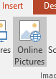

*Figure 84-online pictures button*

1. Select the picture and insert in the slide.
2. After inserting picture, add text box and change its shape to circle and enter numbers in it as inputs and outputs.

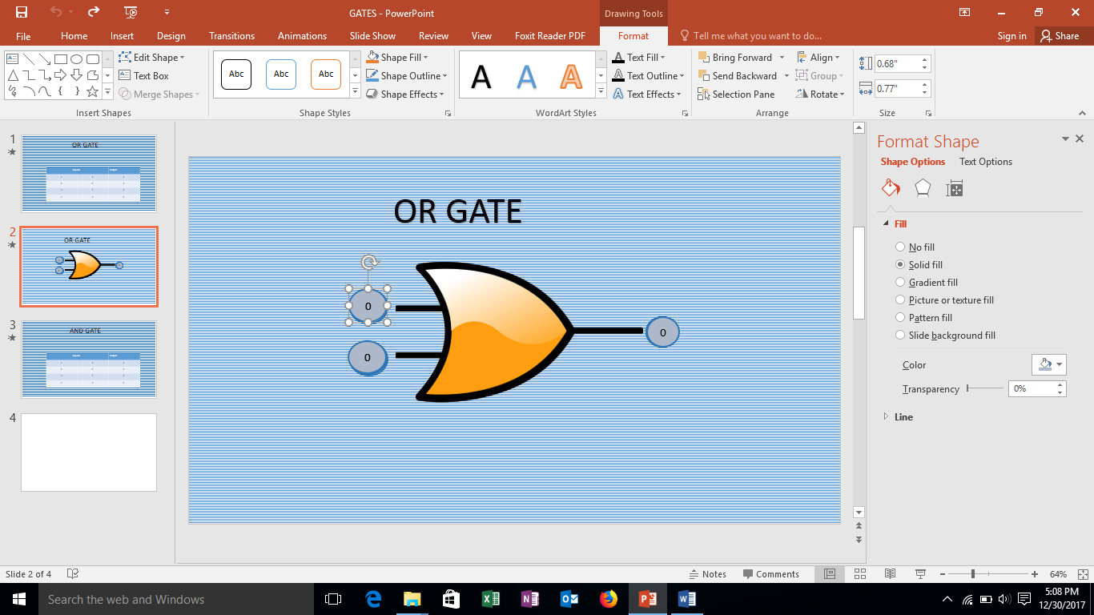

*Figure 85-text box*

1. Format the shape of the text box and text in the shape from the **format bar** which is activated by double clicking the shape.
2. Now apply animations on the gate and **text boxes**. Apply float in, pulse and **fly out** to all. And adjust their sequence. To change bit sequence, select the gate and text boxes one by one and duplicate them along with their animation.

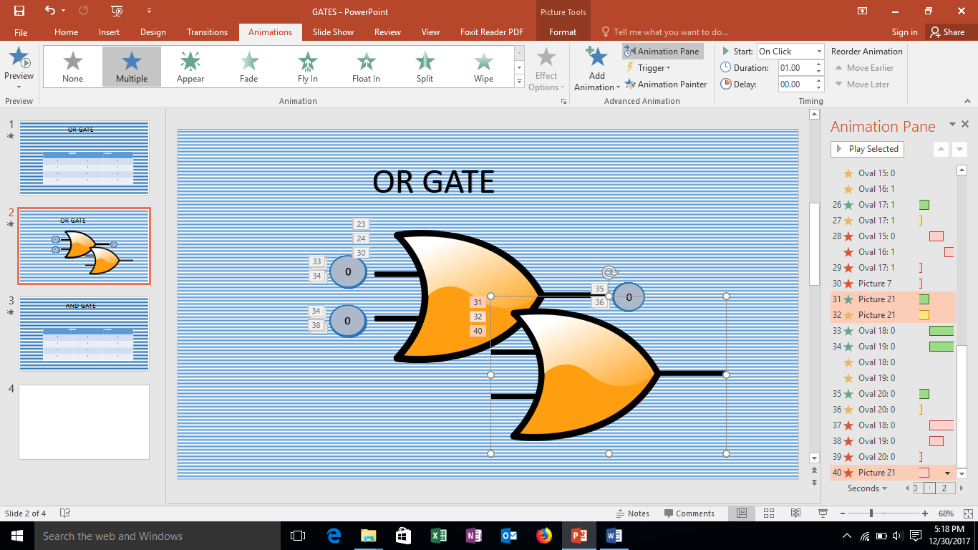

*Figure 86-duplicating shapes and picture*

1. To duplicate the picture and shapes, select them one by one and press **Ctrl+D**. Duplicate the gate and text boxes four times and place them one on the other.
2. Adjust the sequence of the animation in the animation pane.

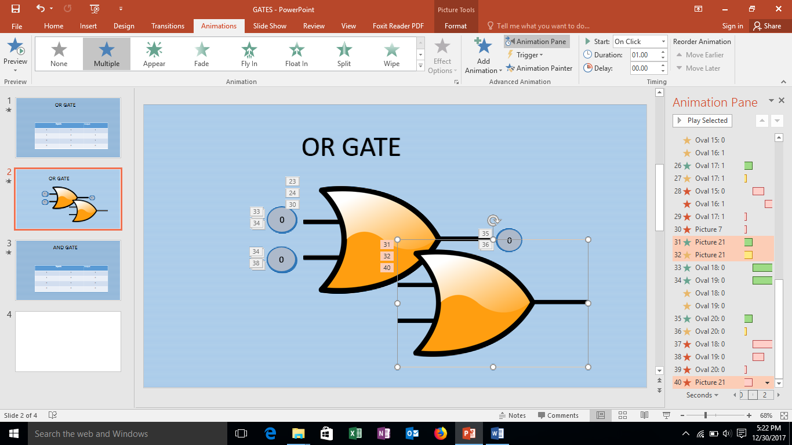

*Figure 87-defining sequence of animations*

1. After completing two slides, check the slide show and correct the mistake if there is any. Define the **duration** and **delay** for each state of the gate.
2. Similarly, make AND and XOR gates and apply **animation** to them.

**Conclusion**

After following the above steps, we are able to apply animations, transitions to values also.